Messages
CHAIRMAN OF FEU DR. NICANOR REYES SCHOOL OF MEDICINE ALUMNI FOUNDATION (FEUDNRSMAF)

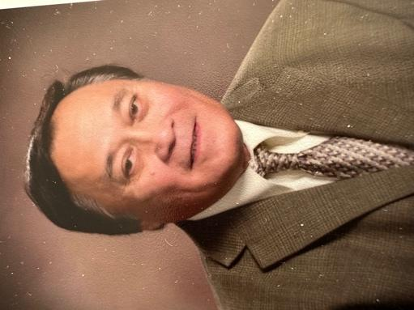

Manuel A. Malicay, MD, FACP, FAHA, Class ‘72

How FEU-NRMF Can Become One of the Top Ten Medical Schools

The Philippine Licensure Examination (PLE) results were released in October 2024. FEUNRMF ranked 8th but was not included in the top ten performing medical schools because its overall passing rate fell short of the required threshold. This is a major concern, as FEUNRMF has consistently ranked among the top five medical schools for decades.

The recent PLE examinees included both fresh FEUNRMF graduates and repeat takers who had previously failed the exam. While our new graduates performed well, the repeaters significantly lowered the overall passing rate. Unofficially, only 10% of every 100 repeaters passed the exam.
During two consecutive meetings at the Annual Alumni Homecoming with the administration—led by President and COO Mr. Juan Enrique J. Reyes, Dean Rey De Los Reyes, MD, and all department chairs—the issue of improving our performance and reclaiming our position among the top medical schools was a key agenda. Since repeaters continuously take the PLE, the Faculty has implemented a specialized review course for them, but attendance has been only around 50%.
From the outset of our discussions, I proposed developing a comprehensive Review Book for both new graduates and repeaters. This book would include well-structured questions, answers, and brief explanations, authored by experts from all basic and clinical departments. Some departments have already compiled review materials. I have personally committed to funding the printing of this book, and Dr. Danny Fabito has also expressed interest in sharing the costs. This book will be provided free of charge to all FEUNRMF graduates preparing for the PLE, ensuring that even those who do not attend the review course have access to essential resources. Those who have previously failed the exam are our brothers and sisters, and it is our duty to support them in achieving their dream of becoming licensed physicians.
The Faculty: Our Most Valuable Asset
Our faculty plays a critical role not only in preparing students for the PLE but also in shaping them into excellent, competent, and compassionate physicians. Dean Rey De Los Reyes, MD, is confident in the faculty’s qualifications, competence, and dedication as educators. Faculty development is a priority, with required participation in seminars and workshops on medical education, particularly in teaching and learning strategies. Faculty members are evaluated by students, peers, and the administration at the end of each semester.
Currently, the School of Medicine has 333 faculty members:
- 52 full-time (24 in basic sciences, 28 in clinical sciences)
- 281 part-time (30 in basic sciences, 251 in clinical sciences)
Faculty members are encouraged to pursue graduate studies (Master’s or PhD programs), with 105 having already graduated, 25 currently enrolled in Master’s programs, and 4 pursuing PhDs. The Dean has requested financial support for faculty members engaged in further studies. While faculty salaries at FEUNRMF are competitive with those at UERMMC, DLSUMH, and CIM, institutions like USTFM and SLMCCM offer higher compensation.

Strengthening Faculty Incentives
In recent years, the FEUDNRMSAF Faculty Incentive Grant has significantly supported our educators:
- $17,500 in previous years
- $20,000 this year
These funds are distributed among faculty members based on their teaching load. To encourage and motivate our faculty in their outstanding work, we must sustain and increase this incentive grant. I have personally initiated funding for this program, hoping that fellow alumni will also contribute. Ideally, the administration can match the alumni-funded incentive grant annually.

A Collective Effort: Administration, Faculty, and Alumni
The success of our medical school rests on three pillars: the administration, faculty, and alumni. The administration and faculty continue to provide the highest quality medical education. As alumni, it is our responsibility to give back generously and sustain our unwavering support for the faculty and the institution. By working together, we can ensure FEUNRMF reclaims its place among the top medical schools in the country.

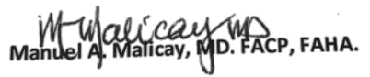
Chairman of the Board, FEUDNRSMAF

